

Reentry Resource Manual

District 7

Boone, Kenton, and Campbell County

Division of Reentry Services


Revised 1/19/26
This resource guide is meant to assist staff in referring clients to the necessary services in the community.

Reentry Directory

NAME | WORK LOCATION | EMAIL | PHONE
Penny Stacy Reentry Coordinator | Probation & Parole District 7  103 Landmark Drive  STE 100  Bellevue, KY 41073 | Penny.Stacy@ky.gov | (859)-206-9062
William Wild Reentry Employment Program Admin (REPA) | Probation & Parole District 7  103 Landmark Drive  STE 100  Bellevue, KY 41073 | William.Wild@ky.gov | (859)-391-7593
Jarvis Livingston Region 5 Program Admin | Probation & Parole 2202 Commerce Pkwy  LaGrange, KY 40032 | Jarvis.Livingston@ky.gov | (502)-564-6244  (859)-327-5321

Probation and Parole Office

District 7  Boone, Kenton, and Campbell Taliyah Jefferson, District Supervisor Doug Hughes-AS; Megan Schubert-AS; Grant Hollenbach-AS; Ralph Stevens-AS | 103 Landmark Drive, STE 100/200 Bellevue, KY 41073  859-292-6555

Reentry Programs/Classes
Please visit The Kentucky Department of Corrections Course Catalog of Offender Programs and Education for program summaries, admission criteria, program content, time frames, policies, and locations.
The Reentry Coordinator in District 7 Facilitates Reentry Programming, the following is the current schedule of program offerings- (* Schedule subject to change, contact your Reentry Coordinator for the most updated schedule).

Program Name | Schedule | Email to Enroll
MRT-Thinking for Good | Monday, 10:00AM Virtual | penny.stacy@ky.gov
MRT-Trauma for Women | Monday, 1:00PM Virtual | penny.stacy@ky.gov
MRT | Tuesday, 10:00AM Virtual | penny.stacy@ky.gov
MRT-Anger Management | Tuesday, 1:00PM Virtual | penny.stacy@ky.gov
MRT-Anger Management | Tuesday, 4:00PM In-Person | penny.stacy@ky.gov
MRT | Wednesday, 4:00PM  In-Person | penny.stacy@ky.gov
MRT | Thursday, 4:30PM  Virtual | penny.stacy@ky.gov

Circuit Court Judges
Boone County
Hon. Richard Bruggemann-Division I | 859-817-5800
Hon. J.R. Schrand-Division | 859-817-5810
Kenton County
Hon. Kathleen Lape-Division 1 | 859-292-6538
Hon. Mary Malloy-Division 3 | 859-292-6530
Hon. Patricia Summe-Division 4 | 859-292-6531
Campbell County  Hon. Julia Reinhardt-Ward-Division 1 | 859-292-6301
Hon. Dan Zalla-Division 2 | 859-292-6303
District Court Judges
Boone County
Hon. Marcia Thomas | 859-817-5830
Hon. Jeffrey Smith | 859-817-5830
Kenton County
Hon. Ruttle | 859-292-6576
Hon. Grothaus | 859-292-6576
Hon. Easterling | 859-2926576
Campbell County
Hon. Sizemore | 859-292-6322
Hon. Blau | 859-292-6322
Commonwealth Attorney’s
E. Rob Sanders (Kenton County) | 859-292-6580
Paul McAndrews (Campbell County) | 859-292-6490
Louis Kelly (Boone County) | 859-586-1723
Public Defenders Office
Kenton County | 859-292-6569
Campbell County | 859-261-0296
Boone County | 859-282-0818

Local Police Departments |  | Dispatch Centers
Bellevue Police Department | 859-261-1122 | 859-292-3622
Boone County Sheriff Department | 859-3342119 | 859-371-1234
Campbell County Police | 859-292-3622 | 859-292-3622
Covington Police | 859-292-2222
 | 859-292-2234 | Detectives
 | 859-292-2230 | Records
Erlanger Police | 859-727-2424
Florence Police | 859-647-5420
Ft Thomas Police | 859-261-1122
Ft Mitchell Police | 859-331-2823
Newport Police | 859-292-3622
 | 859-292-3627 Detectives
 | 859-292-3634 Records
Taylor Mill Police | 859-581-1192
KY State Police (5) | 502-532-6363
KY State Police (6) | 859-428-1212
INS (Louisville) | 502-582-6526
NKDSF | 525-6272
DEA (Cincinnati) | 513-684-3671

Sheriffs Departments |  | Pre Trial Services
Kenton County | 859-392-1800 | 859-292-6518
Campbell County | 859-292-3833 | 859-292-6515
Boone County | 859-334-2175 | 859-817-5860

Probation and Parole Offices
Bellevue |  | 859-292-6555
Federal Probation |  | 859-392-7934
Ohio Adult Parole Authority |  | 513-821-4804
Public Defender Offices
Boone County |  | 859-282-0818
Campbell County |  | 859-261-0296
Kenton County |  | 859-292-6596
 | Central Office
Parole Board |  | 502-564-3620
Offender Records |  | 502-564-2433

Department of Corrections=Addiction Services of Kentucky
(DOC Approved Inpatient Facilities in NKY)

Brighton Recovery Center for Women 375 Weaver Road
Florence, KY 41042
Phone: 859-282-9390

Grateful Life Center 305 Pleasure Isle Drive Erlanger, KY 41018
Phone: 859-359-4500

VA Domiciliary
South Fort Thomas Ave, Fort Thomas, KY 41075
859-572-6202

Northern Kentucky Central AA Office
1545 Scott Boulevard
Covington, KY 41011

859-491-7181 (https://www.nkyaa.info)

KTAP (Kentucky Transitional Assistance Program)

Kentucky Transitional Assistance Program (KTAP) is the monetary assistance program established using federal funds from the Temporary Assistance for Needy Families (TANF) block grant. KTAP provides financial and medical assistance to needy dependent children in Kentucky and the parents or relatives with whom the children live. KTAP also helps families find jobs or get training that leads to a job. A family can receive KTAP benefits for 60 months (five years) in a lifetime. Each month a family receives KTAP benefits counts toward the 60-month lifetime limit. For example, a family may receive KTAP benefits for 24 months, stop and later receive 36 more months of benefits.
Supportive Services
KTAP payments to families are based on family size and income. In addition to the monetary grant, KTAP recipients also may qualify for supportive services such as childcare and transportation assistance through the Kentucky Works program.
Some other benefits available to qualified KTAP recipients include:
Vehicle Repair and Expenses- Up to $3,000 and can pay up to 6 months of vehicle insurance (each 12 months)
Transportation (monthly)
-Five days or less a month is $50
-Six days or more in a month is $300
Access to Child Care costs assistance
$500 Educational Bonus
Access to UKTAP to help remove barriers to work
$600 allowance for various fees related to work, school, or volunteering responsibilities (i.e., school supplies, uniforms, shoes, etc.)
Up to $1500 Relocation Assistance (RAP)
Work Incentive Funds (WIN) - $200 for up to 12 cumulative months
Fee Payments- up to $400 (testing fees, parking passes, job training fees, etc.) Source https://apps.legislature.ky.gov/law/kar/titles/921/002/017/
CONTACT: Roger McCann, Director, Division of Family Support, 502-564-3440
Requirements
To qualify for KTAP, an applicant must have low or very low income, be a Kentucky resident,
U.S. citizens or qualified alien, unemployed or under employed (working for very low wages), a parent/relative caregiver responsible for children up to age 18 (or 19 if school attendance requirements are met).

CABINET FOR HEALTH AND FAMILY SERVICES (CHFS)
Department of Community Based Services (DCBS)
The department provides family support; childcare; child and adult protection; eligibility determinations for Medicaid and food benefits; and administration of an energy cost-assistance program. With offices in every county, the department provides services and programs to enhance the self-sufficiency of families; improve safety and permanency for children and vulnerable adults; and engage families and community partners in a collaborative decision-making process.

Mission
The mission of the Department for Community Based Services is to build an effective and efficient system of care with Kentucky citizens and communities to: Reduce poverty, adult and child maltreatment and their effects; Advance person and family self-sufficiency, recovery, and resiliency; Assure all children have safe and nurturing homes and communities; and Recruit and retain a workforce and partners that operate with integrity and transparency.

Child/Adult Protective Services Reporting

To report child/adult abuse and neglect call: (877) 597-2331 or (800) 752-6200

To report child/adult abuse and neglect online make a report here:
https://prd.webapps.chfs.ky.gov/reportabuse/OutofHours.aspx

Office of the Ombudsman and Administrative Review (OOAR) CHFS & DCBS
The CHFS Ombudsman and Administrative Review (OOAR) is an advocate for citizens and works to ensure those seeking public services are treated fairly.
They answer questions about CHFS programs, investigate customer complaints and work with CHFS management to resolve them, advise CHFS management about patterns of complaints and recommend corrective action when appropriate.

The Office of the Ombudsman aims to be conscientious and responsive and provide meaningful feedback to Cabinet staff to improve customer service and satisfaction and Cabinet effectiveness.

Contact Information

Phone:(502) 564-5497 Toll Free:(800) 372-2973
Fax:(502) 564-9523

Mailing Address
275 E. Main Street, 2E-O Frankfort, KY 40621
Office of the Ombudsman Administrative Review Email CHFS.Listens@ky.gov

Long-Term Care Ombudsman
The Kentucky Long-Term Care Ombudsman program advocates for residents of nursing homes, personal care homes and family care homes, improving care and encouraging positive change at all levels.
Far too many long-term-care residents suffer psychological, physical, and other types of abuse and neglect. More than 80 trained volunteer ombudsmen regularly visit Kentucky long-term care facilities, monitor conditions, and care and give a voice to those unable to speak for themselves.
Use the ombudsman listing by county to find a LTC ombudsman in your area.
Long-term care ombudsman services are coordinated through the Office of the State Long Term Care Ombudsman. The program also oversees 15 district programs affiliated with Area Agencies on Aging and Independent Living. The program receives federal, state and local funding and does not charge for services.

Responsibilities
The responsibilities of long-term care ombudsmen include: Identifying, investigating and resolving complaints made by or on behalf of residents; Providing information to residents about long-term care services; Representing the interest of residents before governmental agencies and seeking administrative, legal and other remedies to protect residents; Analyzing, commenting on and recommending changes in laws and regulations pertaining to the health, safety, welfare and rights of residents; Educating and informing consumers and the general public about long-term care issues and concerns and facilitating public comment on laws, regulations, policies and actions; Promoting development of citizen organizations to participate in the program; Providing technical support to develop resident and family councils that protect the well- being and rights of residents; and Advocating for changes to improve residents’ quality of life and care.

Contact Information
Phone:(859) 277-9215 Toll Free:(800) 372-2991
Fax:(859) 272-0060
Mailing Address: 3138 Custer Drive, Suite 110, Lexington, KY 40517
Kentucky Long-Term Care Ombudsman (DAIL): Sherry Culp, State Long-Term Care Ombudsman Email: sherryculp@ombuddy.org

How to Find a Kynector
Use this search tool to find a kynector or please call 855-4kynect (1- 855-459-6328). Kynect resources is the place for storm victims and anyone who needs help and access to support programs in your area such as food, transportation, housing, employment, finances, physical and mental health and much more.
For a list of current KYNECTORS, visit: https://kynect.ky.gov/benefits/s/auth-reps-assisters?language=en_US (Search by “County”)

Sandy Deaton, KYNECT Program Manager
1116 N Main St, Williamstown, KY 41097 859-242-1992 sdeaton@nkcac.org

Kynector’s | County | Phone | Email
Tammie Wade | Grant | 859-957-9694 | twade@nkcac.org

Vickie Flynn Kenton 859-380-5405 vflynn@nkcac.org
Seliza Krull Kenton 859-653-0279 skrull@nkcac.org
Tiffany Armstrong Boone 859-207-5591 armstrongt@nkcac.org
Jillian Connelly Campbell 859-652-5217 jconnelly@nkcac.org

SNAP (Supplemental Nutrition Assistance Program)

The Supplemental Nutrition Assistance Program (SNAP) helps low-income people buy food for healthy meals at participating stores. Kentucky SNAP benefits increase household food buying power when added to the household's income.
The following people must be included in one household account, regardless of whether they purchase and prepare meals separately:
- A spouse of any household member.
- Parents living with their natural, adopted or stepchildren who are age 21 or younger.
  - Children younger than 18 who are dependents of an adult household member. Eligibility
Any household meeting basic income and other requirements may be able to receive SNAP benefits.
- Citizenship - Only U.S. citizens and some legal foreign residents of the United States may receive food benefits.
- Work Registration - Anyone in a household who is 18 to 59 years old and can work must register for, look for and accept work. There are some exceptions to this requirement.
- Resources - A household may have no more than $2,250 in cash and bank account assets. If a member of the household is 60 or older, the household may have no more than $3,500 in resources. Some resources not used to calculate household assets include the dwelling, its
contents and personal belongings. Vehicles are also excluded.
- Income - The amount of money a household can receive and still be eligible to receive SNAP benefits depends on household size. Money from wages or other payments to any household member is counted as income.
Can I get SNAP benefits right away?
You may qualify for SNAP benefits soon after applying under certain circumstances:
- Your household's monthly rent/mortgage and utilities costs are more than its gross monthly income.
- Your household's gross monthly income is less than $150 and resources, such as cash or bank accounts, total $100 or less.
  - Your household includes members who are destitute migrant or seasonal farm workers.
Legal Rights
As a SNAP applicant, you have the right to:
    - Submit a SNAP application the same day you contact DCBS to apply for this benefit.
      - Receive approval or denial of their SNAP application within 30 days of applying.
        - Receive SNAP benefits within a few days if you meet certain qualifications.
          - Request a fair hearing if you disagree with any action taken in your case.

How to Apply for the Supplemental Nutrition Assistance Program (SNAP)
Supplemental Nutrition Assistance Program (SNAP), formerly known as food stamps, helps low-income people buy food for healthy meals at participating stores. SNAP benefits increase household food buying power when added to the household's income.

Local DCBS Family Support Offices Boone County
Address: Victory Centre 8311 US Hwy 42,
1st Floor Florence KY, 41042
Office Hours: Monday-Friday, 8:00am - 4:30pm Family Support Call Lines (859) 371-6900
Email: kyadvocacy@gmail.com

Kenton County
Address: 130 W. 43rd Street Covington, KY 41015
Office Hours: Monday-Friday, 8:00am - 4:30pm Family Support Call Lines (855) 306-8959
Fax: Family Support (859) 292-6365

Campbell County
Address: Water Tower Square, 601 Washington Ave Newport KY, 41071 Family Support & Foster Care 4th Floor
Office Hours: Monday-Friday, 8:00am - 4:30pm Family Support Call Lines (855) 306-8959

WIC (Women, Infants, and Children)

WIC is a supplemental food program that provides nutrition counseling, breastfeeding support, education, nutritious foods and referrals to healthcare services. WIC improves the health of pregnant, breastfeeding, postpartum women, infants and children up to age 5.

Eligibility for WIC

Persons who receive Medicaid or SNAP automatically meet the income requirements for the WIC Program.
Income Guidelines Effective April 2025

Household  Size | Annually | Monthly | Twice-  Monthly | Biweekly | Weekly
1 | $28,953 | $2,413 | $1,207 | $1,114 | $557
2 | $39,128 | $3,261 | $1,631 | $1,505 | $753
3 | $49,303 | $4,109 | $2,055 | $1,897 | $949
4 | $59,478 | $4,957 | $2,479 | $2,288 | $1,144
5 | $69,653 | $5,805 | $2,903 | $2,679 | $1,340
6 | $79,828 | $6,653 | $3,327 | $3,071 | $1,536
7 | $90,003 | $7,501 | $3,751 | $3,462 | $1731
8 | $100,178 | $8,349 | $4,175 | $3,853 | $1,927

*Persons who receive Medicaid or SNAP automatically meet the income requirements for the WIC Program.

How do I apply for WIC?
Contact your local health department.
Campbell County Health Center | 1098 Monmouth Street, Newport, KY 41071 | 859-431-1704 Kenton County Health Center | 2002 Madison Avenue Covington, KY 41014 | 859-431-3345 Boone County Health Center | 7505 Burlington Pike Florence, KY 41042 | 859-363-2060
Staff will:
Ask for your identity and residence. You will be asked to show ID and proof of Kentucky residency.
Ask your household income to see if you meet income guidelines. You will meet these if you show proof of any of the following: You receive SNAP, KTAP, or Medicaid, or
A pregnant woman or infant in your household receives Medicaid, or A member of your household receives KTAP, or
Have a household income equal or less than 185% of the U.S. Poverty Income Guidelines.
Do a simple health and diet screening to see if you have a nutritional or health risk.
WIC Pre-Screening Tool: WIC Pre-Screening Tool (usda.gov) English, Español and multiple other languages
WIC Farmers Market Nutrition Program
Since 1992, the WIC Farmers Market Nutrition Program has promoted local farmers markets and helped bring locally grown fresh fruits and vegetables into the homes of WIC participants. Each summer, local health departments issue $30 to eligible WIC recipients for the purchase of locally grown fruits, vegetables and fresh-cut herbs. We have 126 Farmers Markets in 79 counties across Kentucky accepting WIC farmers market benefits.
Notice
Need help? If you have difficulty understanding or reading English or have a disability, free language assistance or other aids and services are available upon request. Please contact your local WIC clinic or the State WIC Office at (877) 597-0367. If you have a disability and need assistance calling us, contact the State Relay Number at 711 or for TTY to voice, call (800) 648- 6056.

SHIP (State Health Insurance Assistance Program)

The Kentucky State Health Insurance Assistance Program (SHIP) provides information, counseling and assistance to seniors and disabled individuals, their families, and caregivers. This service is provided at no charge by local, well-trained counselors.
The program seeks to educate the general public, and Medicare beneficiaries, so they are better able to make informed decisions about their health care. SHIP does not sell any health insurance products.

SHIP Goals

Educate seniors on health insurance coverage, benefits, and consumer rights.
Provide assistance, and education on a one-on-one basis or through educational forums.
Protect consumers against fraud or misdirected collections; and Empower consumers to make informed health insurance choices.

Services provided by SHIP

One-on-one counseling by telephone or in person.
Presentations to community groups.
Printed educational and informational materials; and Referrals (connections to other agencies).

What can SHIP do for you?

The KY SHIP has partnered with the Department for Public Health Kentucky Prescription Assistance Program (KPAP) to become a partner site. The KPAP helps qualified persons access prescription drug programs offered by drug manufacturers, discount programs and discount pharmacy programs.
Through the KPAP partnership, SHIP will help those who qualify and/or their families access available prescription drugs for free or at reduced cost. Our service area includes all 120 counties.
Please call the statewide SHIP Hotline at (877) 293-7447 (option #2) or call DAIL at (502) 564- 6930 and ask for a SHIP counselor.

Child Support
Kentucky Child Support Enforcement has an interactive website where you can apply for child support services, estimate a child support obligation, make your child support payments, report address changes, upload court orders and other legal documents, verify payment history and past due child support amounts and request updates on ongoing child support actions.
Child Support Enforcement in the Department for Income Support provides assistance to parents with minor children seeking financial support from a noncustodial parent. Every child has a legal right to financial support from both parents. Here are some Frequently Asked Questions about Child Support

How to Apply for Child Support Enforcement Services
Child support enforcement services are automatically provided to current and former recipients of K-TAP and public medical assistance. Your K-TAP caseworker will refer your case to the appropriate child support office.
Those not receiving K-TAP or medical assistance can apply for child support enforcement services on the Kentucky Child Support interactive website or go to their local office to complete an application for child support services.

The following forms should also be completed by the applicant:
Authorization and Acknowledgement of No Legal Representation explains that county attorneys employed by the Cabinet for Health and Family Services represent the state and not the applicant.
Custodial Parent Affidavit is a sworn statement of the amount of support paid to the custodial parent.
Authorization for Electronic Deposit of Child Support Payments

How to Calculate Your Child Support Obligation

A calculation tool is available on the Kentucky Child Support Interactive Website.
You also may use the following forms to calculate the amount of child support a noncustodial parent must pay. The CS-71.1 is only used when one parent has 100 percent of the total income for the family. When printing these forms, you must also print a copy of the Child Support Guidelines Table to complete the worksheet.
CS-71 - Worksheet For Monthly Child Support Obligation
CS-71.1 - Worksheet For Monthly Child Support Obligation Exception CS-71 - Worksheet For Monthly Child Support Obligation in (Spanish)
CS-71.1 - Worksheet For Monthly Child Support Obligation Exception (Spanish)

Child Support Guidelines
Where to Send Child Support Payments
Payments can be made on the Kentucky Child Support Interactive Website. Please make checks payable to the Kentucky Child Support Enforcement Program and send to the following address:
P.O. Box 14059 Lexington, KY 40512-4059

How to Request a Review and Modification
A written request for a review must be submitted to the local child support office handling your case, along with income information such as W2s, tax returns, and pay stubs. Proof of day care expenses and health insurance costs should also be provided with the review request whenever possible.
There must be a substantial and continuing change that results in the support obligation going up or down by 15% or more before the local office will file a legal action to change the amount.

If a participant on a case requests an increase in child support and it is found that the new child support amount actually qualifies for a decrease, the child support office may then proceed with action to decrease the child support. The same applies when a participant requests a decrease, and the case actually qualifies for an increase.

Private Wage Withholding Cases
Private attorneys must use the Federal Income Withholding Order to notify an employer of an income withholding. Private attorneys refer to the Procedural Instructions to complete the form for a Kentucky child support order.

Child Support Contacts

Child Support Enforcement Hotline
(800) 248-1163, available 8 a.m. - 4:30 p.m. Eastern time

Custody and Visitation Hotline
(844) 673-3470, available 9a.m. - noon and 1 - 5 p.m., Monday-Friday

KY Paternity Acknowledgement Program
(502) 564-2285

KY New Hire Reporting Center
(800) 817-2262

Kentucky New Hire Reporting website CHFS Office of the Ombudsman
(800) 372-2973

Kentucky Medicaid

What is the Medicaid program?
Good health is important to everyone. If you can't afford to pay for medical care right now, Medicaid can make it possible for you to get the care that you need so that you can get healthy and stay healthy.
Medicaid is available only to certain low-income individuals and families who fit into an eligibility group that is recognized by federal and state law. Medicaid does not pay money to you; instead, it sends payments directly to your health care providers.
Depending on your state's rules, you may also be asked to pay a small part of the cost (co-payment) for some medical services. In general, you should apply for Medicaid if you have limited income and resources.

You must match one of the descriptions below:
Pregnant Women
Apply for Medicaid if you think you are pregnant. You may be eligible if you are married or single. If you are on Medicaid when your child is born, both you and your child will be covered.
Children and Teenagers
Apply for Medicaid if you are the parent or guardian of a child who is 18 years old or younger and your family's income is limited, or if your child is sick enough to need nursing home care, but could stay home with good quality care at home. If you are a teenager living on your own, the state may allow you to apply for Medicaid on your own behalf or any adult may apply for you. Many states also cover children up to age 21.
Person who is Aged, Blind, and/or Disabled
Apply if you are aged (65 years old or older), blind, or disabled and have limited income and resources.
Apply if you are terminally ill and want to get hospice services. Apply if you are aged, blind, or disabled; live in a nursing home; and have limited income and resources. Apply if you are aged, blind, or disabled and need nursing home care, but can stay at home with special community care services. Apply if you are eligible for Medicare and have limited income and resources.
Other Situations
Apply if you are leaving foster care and need health coverage. Apply if you are a family with children under age 18 and have limited income and resources. (You do not need to be receiving a welfare check.)

****Federal poverty levels are used to determine your eligibility for certain programs and benefits including Medicaid (see chart below)

Family Size | 2023 Income
1 | $14,508
2 | $19,720
3 | $24,860
4 | $30,000
5 | $35,140
6 | $40,280
7 | $45,420
8 | $50,560
Local DCBS Family Support Offices:

Boone County
Address: Victory Centre 8311 US Hwy 42, 1ST Floor Florence KY, 41042
Office Hours: Monday-Friday, 8:00am - 4:30pm Family Support Call Lines (855) 306-8959
Fax: (859) 371-0265

Campbell County
Address: Water Tower Square, 601 Washington Ave Newport KY, 41071
Family Support & Foster Care 4th Floor Office Hours: Monday-Friday, 8:00am - 4:30pm
Family Support Call Lines (855) 306-8959
Fax: Family Support (859) 292-6684

Kenton County
Address: 130 W. 43rd Street Covington, KY 41015
Office Hours: Monday-Friday, 8:00am - 4:30pm Family Support Call Lines (855) 306-8959
Fax: Family Support (859) 292-6365

KCHIP - Kentucky’s Children’s Health Insurance Program
Children's health is important to everyone, but barriers to health care access may prevent you from coverage. KCHIP is a free health insurance program for children under the age of 19 without health insurance who qualify for help.

Who is eligible?
Uninsured children under 19 who live in families with an income at or less than 218% of the federal poverty level are eligible. Not sure if you qualify? Visit kidshealth.ky.gov to check specific KCHIP income limits.
When determining your income, be sure to calculate before taxes are taken out.
Speak with your employer to confirm your salary or wage.

What is covered by KCHIP?
Prescriptions, well-care checks and immunizations, hospital stays, provider and dental visits, mental health services, glasses and vision care, speech, and physical therapy, and much more.

How do you apply?
Find and print an application at: kynect.ky.gov/benefits Call 1-844-407-8398 toll-free to request an application.
Applications can also be picked up at any local health department, provider's office, hospital, pharmacy, or school.

What do you need to apply?
Proof of income
Proof of expenses for childcare or disabled adult living at home Health insurance information
Proof of citizenship Proof of identity.

KCHIP Income Limits

Number of Family Members (include  parents and children) | Total Monthly Family Income  (before taxes) | Total Annual Family Income  (before taxes)
1 | 2,588 | 31,056
2 | 3,500 | 42,000
3 | 4,413 | 52,956
4 | 5,325 | 63,900
5 | 6,237 | 74,844
6 | 7,150 | 85,800
7 | 8,974 | 96,744
8 | 8,794 | 107,688

Local DCBS Family Support Offices: Boone County
Address: Victory Centre 8311 US Hwy 42, 1ST Floor Florence KY, 41042
Office Hours: Monday-Friday, 8:00am - 4:30pm Family Support Call Lines (855) 306-8959
Fax: (859) 371-0265

Campbell County
Address: Water Tower Square, 601 Washington Ave Newport KY, 41071 Family Support & Foster Care 4th Floor
Office Hours: Monday-Friday, 8:00am - 4:30pm Family Support Call Lines (855) 306-8959
Fax: Family Support (859) 292-6684

Kenton County
Address: 130 W. 43rd Street Covington, KY 41015
Office Hours: Monday-Friday, 8:00am - 4:30pm Family Support Call Lines (855) 306-8959
Fax: Family Support (859) 292-6365

Medicare
Medicare is available for people aged 65 or older, younger people with disabilities and people with End Stage Renal Disease (permanent kidney failure requiring dialysis or transplant).
Medicare has two parts, Part A (Hospital Insurance) and Part B (Medicare Insurance). You are eligible for premium-free Part A if you are age 65 or older and you or your spouse worked and paid Medicare taxes for at least 10 years.

You can get Part A at age 65 without having to pay premiums if:

You are receiving retirement benefits from Social Security or the Railroad Retirement Board.
You are eligible to receive Social Security or Railroad benefits, but you have not yet filed for them.
You or your spouse had Medicare-covered government employment.

Medicare has four parts:

Part A (Hospital Insurance) Part B (Medicare Insurance)
Part C (Medicare Advantage Plans) Part D (Drug Coverage) Parts of Medicare
Part A premium (Hospital Insurance) helps cover:
Inpatient care in hospitals, skilled nursing facility care, hospice care, and home health care. Most people don’t pay a premium for Part A coverage. This is sometimes called “premium-free
Part A.” You won’t pay a Part A premium if you:
Qualify to get (or are already getting) retirement or disability benefits from Social Security (or the Railroad Retirement Board).

Get Medicare earlier than 65.

Are 65 or older and you (or another qualifying person, like your current or former spouse) paid Medicare taxes while working for a certain amount of time (usually at least 10 years).
If you don’t qualify for premium-free Part A, you might be able to buy it.

Medicare cont….

Part B Premium (Medical Insurance) helps cover:

Services from doctors and other health care providers Outpatient care
Home health care
Durable medical equipment (like wheelchairs, walkers, hospital beds, and other equipment) Many preventive services (like screenings, shots, or vaccines, and yearly “Wellness” visits) Part B Premium
You’ll pay a premium for Part B coverage every month, even if you don’t get any Part B-covered
services. The monthly premium can change each year and may be higher depending on your income.
Most people don’t get a bill from Medicare because they get the premium deducted automatically from their Social Security, Railroad Retirement Board, or Civil Service Retirement check. If you don’t get any of these payments, you’ll get a bill for your Part B premium so you can pay Medicare directly.
Estimate your Part A and Part B Medicare eligibility & premiums at this link Eligibility & Premium Calculator | Medicare

Part C premium

Monthly premiums for Part C coverage vary based on which plan you join. The premium amount can change each year.

Part D Premium (Drug coverage)

Since January 1, 2006, everyone with Medicare, regardless of income, health status, or prescription drug usage has had access to prescription drug coverage.
Helps cover the cost of prescription drugs (including many recommended shots or vaccines).
You join a Medicare drug plan in addition to Original Medicare, or you get it by joining a Medicare Advantage Plan with drug coverage. Plans that offer Medicare drug coverage are run by private insurance companies that follow rules set by Medicare.
Monthly premiums for Part D coverage vary based on which plan you join. The premium amount can change each year. You may also have to pay an extra amount each month based on your income.

Eligibility

To find out if you are eligible and your expected premium:

https://www.medicare.gov/ eligibility tool
If you (or your spouse) did not pay Medicare taxes while you worked, and you are age 65 or older and a citizen or permanent resident of the United States, you may be able to buy Part A. If you are under age 65, you can get Part A without having to pay premiums if:
You have been entitled to Social Security or Railroad Retirement Board disability benefits for 24 months. (Note: If you have Lou Gehrig's disease, your Medicare benefits begin the first month you get disability benefits.)
You are a kidney dialysis or kidney transplant patient.
While most people do not have to pay a premium for Part A, everyone must pay for Part B if they want it. This monthly premium is deducted from your Social Security, Railroad Retirement, or Civil Service
Retirement check. If you do not get any of these payments, Medicare sends you a bill for your Part B premium every 3 months.

Medigap - Medicare Supplemental Insurance

Extra insurance you can buy from a private company that helps pay your share of costs in Original Medicare. Policies are standardized, and in most states named by letters, like Plan G or Plan K. The benefits in each lettered plan are the same, no matter which insurance company sells it.

Your Medicare options
When you first sign up for Medicare and during certain times of the year, you can choose which way to get your Medicare coverage.

There are 2 main ways

Original Medicare  Original Medicare includes Part A and Part B.  You can join a separate Medicare drug plan to get Medicare drug coverage (Part D).  You can use any doctor or hospital that takes Medicare, anywhere in the U.S. To help pay your out-of-pocket costs in Original Medicare (like your 20% coinsurance), you can also buy supplemental coverage, like Medicare Supplement Insurance (Medigap), or have coverage from a former employer or union, or Medicaid | Medicare Advantage (also known as Part C)  Medicare Advantage is a Medicare- approved plan from a private company that offers an alternative to Original Medicare for your health and drug coverage. These “bundled” plans include Part A, Part B, and usually Part D.  In most cases, you’ll need to use doctors who are in the plan’s network. Plans may have lower out-of- pocket costs than Original Medicare.  Plans may offer some extra benefits that Original Medicare doesn’t cover  — like vision, hearing, and dental  services.

What’s the difference between Medicare & Medicaid?
Medicare is a medical insurance program for people over 65 and younger disabled people and dialysis patients. Medicaid is an assistance program for low- income patients' medical expenses for those under 65 with certain disabilities or conditions. Medicaid is a joint federal and state program that provides health coverage for some people with limited income and resources. Medicaid offers benefits, like nursing home care, personal care services, and assistance paying for Medicare premiums and other costs.
*If you qualify, you can have both Medicare and Medicaid.

Social Security Disability Income (SSDI) & Retirement, Survivors, and Disability Insurance (RSDI)

The Basics About Disability Benefits
The SSDI program pays benefits to you and certain family members if you are “insured.” This means that you worked long enough – and recently enough - and paid Social Security taxes on your earnings. The SSI program pays benefits to adults and children who meet our requirements for a qualifying disability and have limited income and resources. While these two programs are different, the medical requirements are the same. If you meet the nonmedical requirements, monthly benefits are paid if you have a medical condition expected to last at least one year or result in death.

How to apply:
Whether you apply online, by phone, or in person, the disability benefits application process follows these general steps:
You gather the information and documents you need to apply. We recommend you print and review the Adult Disability Checklist. It will help you gather the information and documents you need to complete the application.
  - You complete and submit your application.
  - We review your application to make sure you meet our basic requirements for disability benefits.
  - We confirm you worked enough years to qualify.
  - We evaluate any current work activities.
  - We process your application and forward your case to the Disability Determination Services office in your state.
  - This state agency makes the disability determination decision.
  - To learn more about who decides if you have a disability, read our publication Disability Benefits.

Once You've Applied
Processing time for disability applications vary depending on the nature of the disability, necessary medical evidence or examinations, and applicable quality reviews. Once we receive your application, we’ll review it and contact you if we have questions. We might request additional documents from you before we can proceed.

Look For Our Response
When the state agency makes a determination on your case, you’ll receive a letter in the mail with our decision. It generally takes three to six months for an initial decision. If you included information about other family members when you applied, we’ll let you know if they may be able to receive benefits on
your record.

Check The Status
You can check the status of your application online using your personal my Social Security account. If you are unable to check your status online, you can call us 1- 800-772-1213 (TTY 1-800-325-0778) from 8:00 a.m. to 7:00 p.m., Monday through Friday.

Appeal A Decision
You have the right to appeal any decision we make about whether you’re entitled to benefits. You must request an appeal in writing within 60 days after you receive the notice of our decision.

There are four levels of appeal:
Reconsideration.
Hearing by an administrative law judge.
Review by the Appeals Council.
Federal Court Review.

SSDI & RSDI (CON’T)
Learn More or Appeal a Decision Understanding SSI - Appeals Process (ssa.gov) Check Application or Appeal Status Check application or appeal status/ SSA Information You Need to Apply
Before applying, be ready to provide information about yourself, your medical condition, and your work. We recommend you print and review the Adult Disability Checklist. It will help you gather the information you need to complete the application.

Information About You
*Your date and place of birth and Social Security number.
*The name, Social Security number, and date of birth or age of your current spouse and any former spouse. You should also know the dates and places of marriage and dates of divorce or death (if appropriate).
*Names and dates of birth of children not yet 18 years of age.
*Your bank or other financial institution's Routing Transit Number and the account number.

Information About Your Medical Condition
Name, address, and phone number of someone we can contact who knows about your medical conditions and can help with your application.

Detailed information about your medical illnesses, injuries, or conditions:
*Names, addresses, phone numbers, patient ID numbers, and dates of treatment for all doctors, hospitals, and clinics.
*Names of medicines, the amount you are taking, and who prescribed them.
*Names and dates of medical tests you have had and who ordered them.

Information About Your Work
*The amount of money earned last year and this year.
*The name and address of your employer(s) for this year and last year.
*The beginning and ending dates of any active U.S. military service you had before 1968.

SSDI & RSDI (CON’T)
Information You Need to Apply (Con’t)
A list of the jobs (up to five) that you had in the 15 years before you became unable to work and the dates you worked at those jobs.
Information about any workers' compensation, black lung, and similar benefits you filed, or intend to file for.

These benefits can:
*Be temporary or permanent.
*Include annuities and lump sum payments that you received in the past.
*Be paid by your employer or your employer's insurance carrier, private agencies, or federal, state, or other government or public agencies.

Could be referred to as:
*Workers' Compensation.
* Black Lung Benefits.
*Longshore and Harbor Workers' Compensation.
*Civil Service (Disability) Retirement.
*Federal Employees' Retirement.
*Federal Employees' Compensation.
*State or local government disability insurance benefits.
*Disability benefits from the military. These include military retirement pensions based on disability but not Veterans' Administration (VA) benefits.

(SSI/SSDI Cont.)

Apply With Your Local Office
You can do most of your business with Social Security online. If you cannot use these online services, your local Social Security office can help you apply. You can find the phone number for your local office by using our Office Locator and looking under Social Security Office Information. The toll-free “Office” number is your local office.

Apply By Phone
Call 1-800-772-1213 (TTY 1-800-325-0778) from 8:00 a.m. to 7:00 p.m., Monday
through Friday, to apply by phone.
If You Do Not Live in the U.S. Or One of Its Territories
Contact the Federal Benefits Unit for your country of residence if you live outside the U.S. or a U.S. territory and wish to apply for retirement benefits.

Mailing Your Documents
If you mail any documents to us, you must include the Social Security number so that we can match them with the correct application. Do not write anything on the original documents. Please write the Social Security number on a separate sheet of paper and include it in the mailing envelope along with the documents.

FOOD PROGRAMS

USDA COMMODITIES
The Northern Kentucky Area Development District (NKADD) is the state designated food bank for Northern Kentucky. With this designation, NKADD administers and oversees the Commodity Supplemental Food Program (CSFP) and The Emergency Food Assistance Program (TEFAP) in our eight-county region.
The Emergency Food Assistance Program (TEFAP)
The Emergency Food Assistance Program (TEFAP) is a Federally funded program whose purpose is to provide supplemental food to low-income households. The amount of TEFAP commodities received in our region is based on the on the percentage of low- income households and the unemployment rate. Households whose total monthly income is less than 130% of the poverty level, the same scale used to determine eligibility for food stamps, may receive a monthly package of commodity foods. The TEFAP program also provides food to local soup kitchens.
There is no income requirement to receive a meal at a soup kitchen.
Eligibility
To learn more about TEFAP contact a distribution site or soup kitchen in your county. Please note that recipients can receive TEFAP commodities only one (1) time per month – multiple TEFAP site visits in the same month shall result in disqualification from program. There is no restriction on visits to soup kitchens.

INCOME GUIDELINES
Household Size// | Annually | Monthly | Weekly
1 | $18,954 | $1,580 | $365
2 | $25,636 | $2,137 | $493
3 | $32,318 | $2,694 | $622
4 | $39,000 | $3,250 | $750
5 | $45,682 | $3,807 | $879
6 | $52,364 | $4,364 | $1,007
7 | $59,046 | $4,921 | $1,136
For Each Add’l  Family Member | $6,682 | $557 | $129

The Emergency Food Assistance Program (TEFAP) Providers

Boone County
Burlington Baptist - Susan Poston 3031 Washington St
Burlington, KY 41005
859-586-6529
Campbell County
Brighton Center  799 Ann St  Newport, KY 41072  859-491-8303 | Care Mission, Inc  11093 Alexandra Pk  Alexandria, KY 41001  859-635-0818
Holy Spirit Outreach  825 Washington Ave  Newport, KY 41071  859-261-0818 | St. Bernard Food Pantry  401 Berry St  Dayton, KY 41074  859-291-4393
St. John Lutheran Church –
5977 Lower Tug Fork Rd.
Melbourne, KY 41059
859-635-5013
Kenton County
Action Ministries  4375 Baron St  Covington, KY 41015  859-261-3649 | Be Concerned  1100 Pike St  Covington, KY 41011  859-291-1340
Covington Salvation Army 1806 Scott Blvd  Covington, KY 41014  859-261-0835 | Esperanza Latino Center of NKY  234 W Pike St Covington, KY 41011  859-261-0862
Generations Church  4161 Richardson Rd  Independence, KY 41051  859-869-1143 | United Ministries  525 Graves Ave  Erlanger, KY 41018  859-727-0300

Soup Kitchens

Campbell County | Kenton County
Henry Hosea House | Parish Kitchen
901 York St. | 1561 Madison Ave.
Newport KY, 41071 | Covington KY, 41015
(859) 261-5857 | (859) 581-7745

Commodity Supplement Food Program (CSFP)
The Commodity Supplemental Food Program (CSFP) is a Federally funded program with the goal of improving the health of low-income individuals aged 60 or older. This is accomplished by supplementing their diets with a monthly package of nutritious foods to include canned fruits/vegetables, whole grains, proteins, dairy, and fruit juices.

Eligibility
To receive a CSFP package, contact a local distribution site to become certified for the program. If the distribution site’s caseload is full, eligible persons may join the waitlist. Eligible participants will be asked to fill out a form certifying income and showing proof of age and residency, and this certification is valid for six (6) months. CSFP Participants are automatically eligible for the TEFAP program and may receive both one (1) time per month. It is approx. $50.00 worth food.
CSFP Income Guidelines Commodities Program – NKADD (as of 3-10-25)

Income Guidelines
Household Size | Annually | Monthly | Weekly
1 | $23,475 | $1,975 | $452
2 | $31,725 | $2,644 | $611
3 | $39,975 | $3,332 | $769
4 | $48,225 | $4,019 | $928
5 | $56,475 | $4,707 | $1,087
6 | $64,725 | $6,394 | $1,245
7 | $72,975 | $6,082 | $1,404
For Each Add’l  Family Member | $8,250 | $688 | $159

Commodity Supplement Food Program (CSFP) Providers

Boone County
Florence Senior Center  7431 US 42  Florence KY, 41042  (859) 282-4061 | Walton Senior Center  44 N. Main St.  Walton KY, 41094  (859) 485-4383
Campbell County
Brighton Center 741 Central Ave.  Newport KY, 41072  (859) 491-8303 | Campbell Co. Senior Center  3504 Alexandria PK.  Highland KY, 41076  (859) 572-4300
Clifton Hills-Beth Schweinzger  29 18TH St.  Newport KY, 41071  (859) 581-2533 | Grand Towers – Peggy Bramble 1359 Grand Ave.  Newport KY, 41071  (859) 581-2533
Highland Village – Kelly Speier  515 Main Ave.  Highland Heights KY, 41076  (859) 581-2533 | St. John Lutheran Church  5977 Lower Tug Fork Rd.  Melbourne KY, 41059  (859) 635-5013
Kenton County

Covington Salvation Army 1806 Scott Blvd.  Covington KY, 41014  (859) 261-0835 | Hathaway Court Apartments 1200 Highway Ave.  Covington KY, 41011  (859) 491-5301
United Ministries
525 Graves Ave.
Erlanger KY, 41018
(859) 727-0300

Veterans Benefits
KENTUCKY DEPARTMENT OF VETERANS AFFAIRS
KDVA provides professional help free of charge to veterans in obtaining and using federal and state benefits to which they are entitled. They help veterans and their dependents make successful claims for benefits, privileges, rights, and other veteran services. Benefits include access to veterans' nursing homes, burial with honors in veterans’ cemeteries, benefits counseling, and specific assistance for homeless and women veterans.

How to find a KDVA representative

KDVA Benefits Division’s primary mission is to assist veterans and their family members file for their Federal VA Compensation and Pension Benefits. They have Veterans Benefits Field Representatives (VBFR) across the Commonwealth to assist veterans. You can find the closest Claims Representative.

They are:

*Fully accredited
*Full-time professionals
*FREE
*Expert at representing veterans in appeals. You do not need an attorney!

**You should verify accreditation on the VA Office of General Counsel web page: See who is accredited.

Veteran Employment Services

The Kentucky Career Centers have staff, many of whom are veterans themselves, who are specifically trained to assist veterans and transitioning service members find suitable and sustainable civilian employment.

Available Services

Career assessments// Job search assistance//Interview preparation//Labor market information// Resume and cover letter assistance// Access to computers and internet service// Translating military experience to civilian responsibilities// Specialized services for veterans with disabilities through our Office of Vocational Rehabilitation.
If you have questions or require additional information, please email veteranservices@ky.gov

Veterans Health Services
Cincinnati VA Medical Center - Fort Thomas, KY 1000 South Fort Thomas Avenue Fort Thomas, KY 41075-2305 859-572-6202 | Clinical Hours: 24/7
If struggling with issues like PTSD, depression, grief, anger, or trauma, we offer counseling and other support. All VA health care facilities offer same-day help.
You may qualify even without enrolling in VA health care.
Veterans Crisis Line
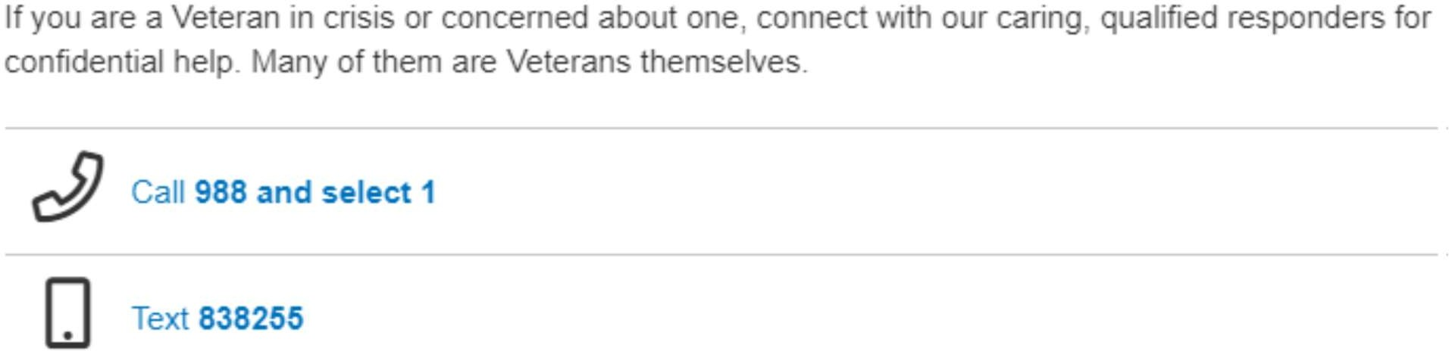

Veteran Housing Assistance
National Call Center for Homeless Veterans: 1-877-424-3838

Who Can Call?
-Veterans who are homeless or at risk of homelessness
-Family members, friends and supporters calling on behalf of Veterans
-VA Medical Centers and other VA facilities and staff
-Federal, state and local partners
-Community agencies and providers who serve Veterans who are homeless

Goodwill’s Services for Veterans
VA Supportive Services for Veteran Families (SSVF): a VA program designed help veterans who may lose their homes or are recently homeless. It provides rapid re- housing to eligible veterans.
VA funded “Per diem” residential program: This is a residential program operated by Ohio Valley Goodwill. The program is funded by the Department of Veterans Affairs. It is available to eligible homeless veterans in need of intensive services and employment assistance on the way to self-sufficiency. All program participants are pursuing full-time employment in their community.

Cell Phones & Internet Connectivity Programs

Affordable Connectivity Program
The Affordable Connectivity Program is an FCC benefit program that helps ensure that households can afford the broadband they need for work, school, healthcare and more. The benefit provides a discount of up to $30 per month toward internet service for eligible households and up to $75 per month for households on qualifying Tribal lands.
Eligible households can also receive a one-time discount of up to $100 to purchase a laptop, desktop computer, or tablet from participating providers if they contribute more than $10 and less than $50 toward the purchase price.
The Affordable Connectivity Program is limited to one monthly service discount and one device discount per household.
Learn more about eligibility and how to enroll at https://www.fcc.gov/acp

Lifeline Cell Phone Program
Since 1985, the Lifeline program has provided a discount on phone service for qualifying low-income consumers to ensure that all Americans have the opportunities and security that phone service brings, including being able to connect to jobs, family, and emergency services. Lifeline is part of the Universal Service Fund.
The Lifeline program is available to eligible low-income consumers in every state, territory, commonwealth, and on Tribal lands.
Eligible consumers can get up to $9.25 off the cost of phone, internet, or bundled services. Find more information and a list of providers:
https://www.fcc.gov/general/lifeline-program-low-income-consumers

OBTAINING ESSENTIAL DOCUMENTS ID OR DRIVERS LICENSE
All identification and licensing services have fully transitioned from the Office of Circuit Court Clerk in every county to Driver Licensing Regional Offices throughout Kentucky.

Identification Card
*An ID card may be obtained for a person aged 15 and over at any Driver Licensing Regional Office.
*A birth certificate, Social Security card (photocopies not accepted), and proof of residency are required. Click here for a list of Valid Proof Documents.
*A parent/guardian must be present if the applicant is under 18 years old.
*The cost of a standard Identification Card at any Driver Licensing Regional office is $11.50.

Homeless Identification Card

The ID card can be obtained at any Driver Licensing Regional office.
Per KRS 186.412(7). Per KRS 186.412 (7), "...the regional office shall issue a color photo personal identification card to any person who is a Kentucky resident and who resides in the county who complies with the provisions of this section and who applies in person." It further states that "An application for a personal identification card shall be accompanied by the same information as is required for an operator license"..." except if a person does not have a fixed, permanent address, the person may use as proof of residency a signed letter from a homeless shelter, health care facility, or social service agency currently providing the person treatment or services and attesting that the person is a resident of Kentucky."

Finding a Licensing Regional Office

Regional Offices are open to in-person visits from any Kentucky resident. Appointments are highly suggested, as limited space for walk-ins differs from site to site. All offices accept Credit/Debit, Cash, Personal Checks, Certified Checks, and Money Orders. Online and mail-in license renewals are now available.

Visit our compare my options tool to determine which option best fits your needs.
Visit https://drive.ky.gov/Pages/Find-An-Office.aspx to find your nearest office
Visit https://drive.ky.gov/Drivers/Pages/Licensing-Transition.aspx for more Licensing Services and Resources information
Visit https://drive.ky.gov/Drivers/Documents/ValidProofDocuments.pdf for a list of acceptable documents

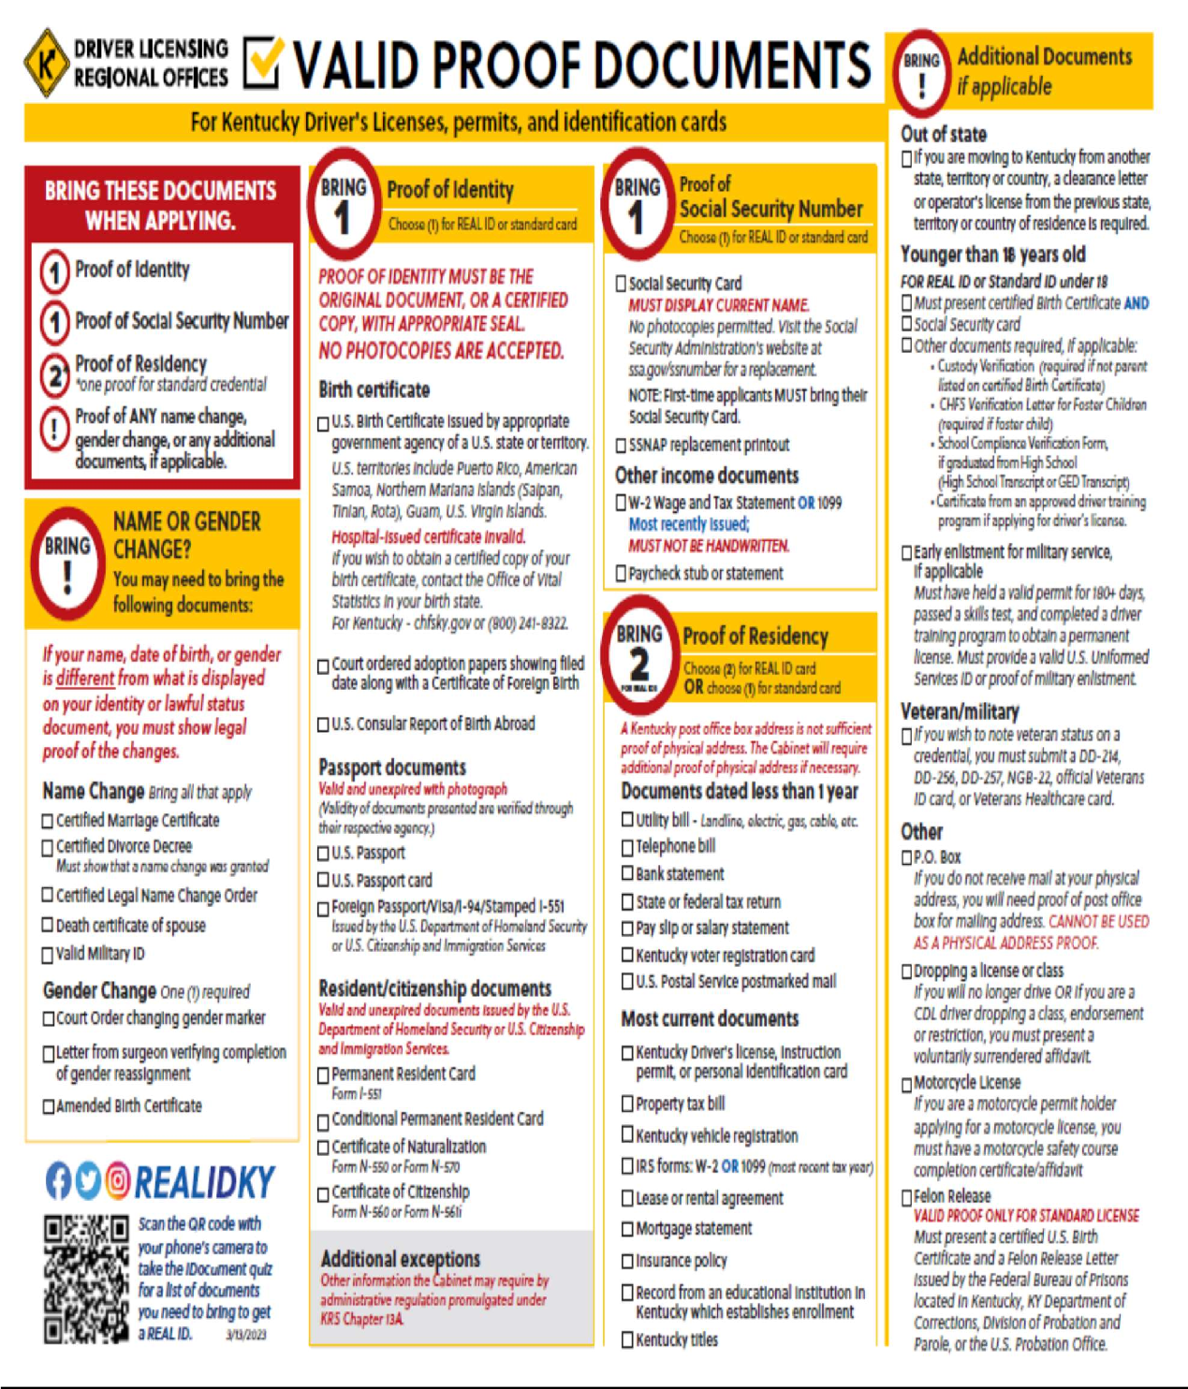

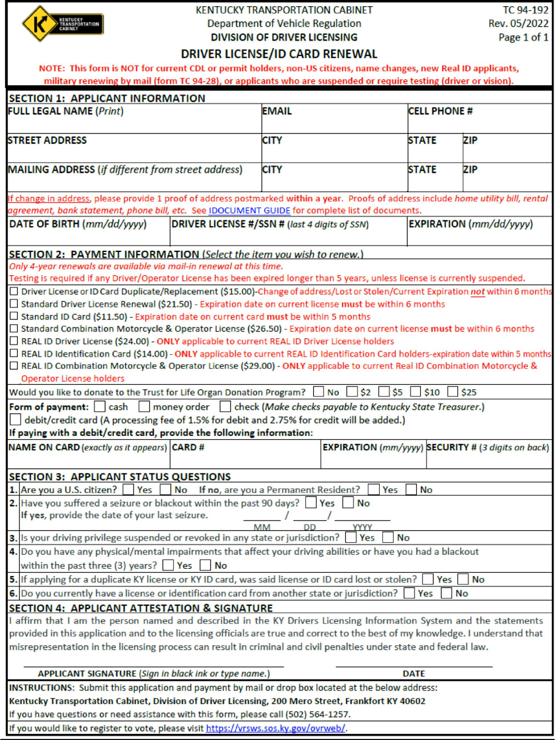

Social Security Number and Card
The Social Security Administration (www.ssa.gov). Has a mass of information regarding more options on how to apply depending on your background of information. Please visit the website in the sources section at the bottom of this information sheet to help you get the information or documents needed information to assist your application process. Below are the main questions you will need to answer on the website. The system will automatically generate what application steps you need to take, replace a card, or request a number for the first time, visit https://www.ssa.gov/number-card
Who is the card for? An adult or a child?
What type of card do you need?
Original, Replacement, or Corrected? Citizenship of the whom the card is for?
U.S. Born Citizen, Foreign Born U.S. Citizen, or a Noncitizen?

Social Security Card; Important
You must present original documents or copies certified by the agency that issued them. We cannot accept photocopies or notarized copies. All documents must be current (not expired). We cannot accept a receipt showing you applied for the document.

What original documents do I need?
- Citizenship: We can accept only certain documents as proof of U.S. citizenship. These include a U.S. birth certificate or a U.S. passport.
- Age: You must present your birth certificate. If one exists, you must submit it.

If a birth certificate does not exist, we may be able to accept your:
Religious record made before the age of five showing your date of birth;
U.S. hospital record of your birth.
U.S. passport.
Anyone age 12 or older requesting an original Social Security number (SSN) must appear in person for an interview. We will ask for evidence to show you do not have an SSN. Here are examples of documents you can use to prove an SSN was never assigned:

(SS CARD Cont.)
If you lived outside the United States for an extended period, a current or previous passport, school and/or employment records, and any other record that would show long-term residence outside the United States could be used to show you do not have an SSN.
If you have lived in the United States and you are applying for an original SSN, we may ask you for information about the schools you attended, or we may ask you to provide copies of tax records that would show you were never assigned an SSN.

Identity
We can accept only certain documents as proof of identity. An acceptable document must be current (not expired) and show your name, identifying information (date of birth or age) and preferably a recent photograph. For example, as proof of identity we must see your:
- U.S. driver's license.
- State-issued non-driver identification card.
- U.S. passport.
Additional Acceptable Documentation
If you do not have one of these specific documents or you cannot get a replacement for one of them within 10 days, we will ask to see other documents. Any documents submitted, including the following, must be current (not expired) and show your name, identifying information (date of birth or age) and preferably a recent photograph:
  - Employee identification card.
  - School identification card.
  - Health insurance card (not a Medicare card)
  - U.S. military identification card.
  - Doctor, clinic or hospital record;
  - Religious record;
  - School daycare center record; or School identification card

US Social Security Administration Offices
7 Youell St, Florence KY, 41042 (8.1 Miles) Phone Number: (800) 772-7813
509 Marketplace Dr, Maysville, KY 41056 (49.1 Miles) Phone Number: (800) 772-
1213
140 Flynn Ave, Frankfort, KY 40601 (63.8 Miles) Phone Number: (866) 964-1724
2241 Buena Vista Rd. Suite 110, Lexington, KY 40505 (71.2 Miles) Phone Number:
(899) 530-7754

Language Assistance:
English/Chinese (Traditional)/Chinese (Simplified)/Farsi/Arabic/French
/Greek/Italian/Korean/Polish/Portuguese/Russian/Tagalog/Vietnamese

Website: The United States Social Security Administration (ssa.gov)

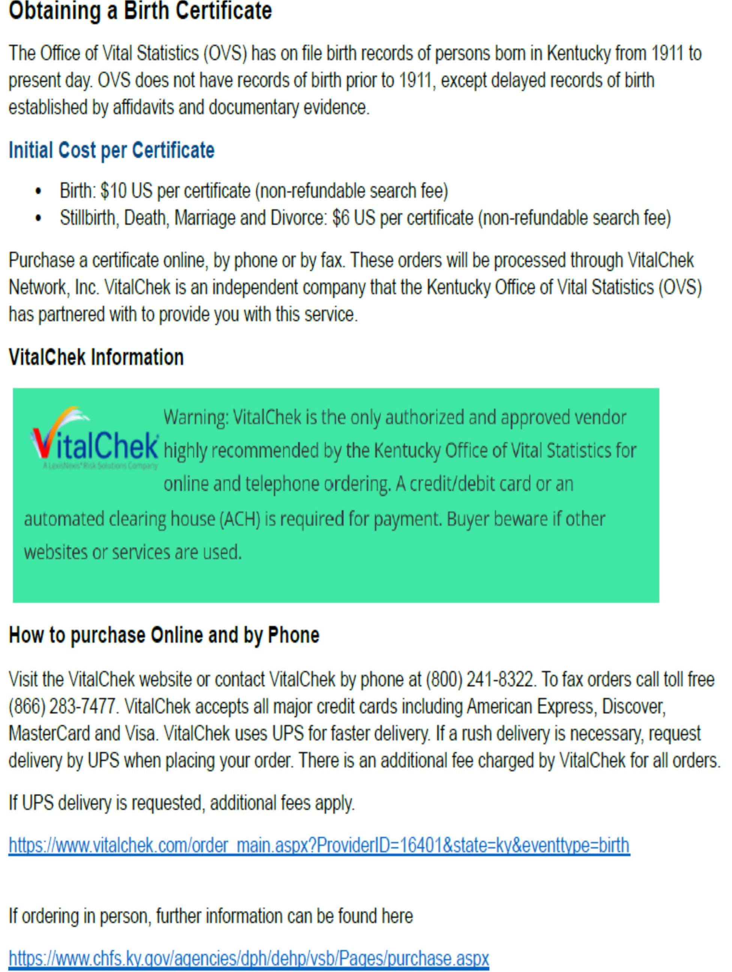

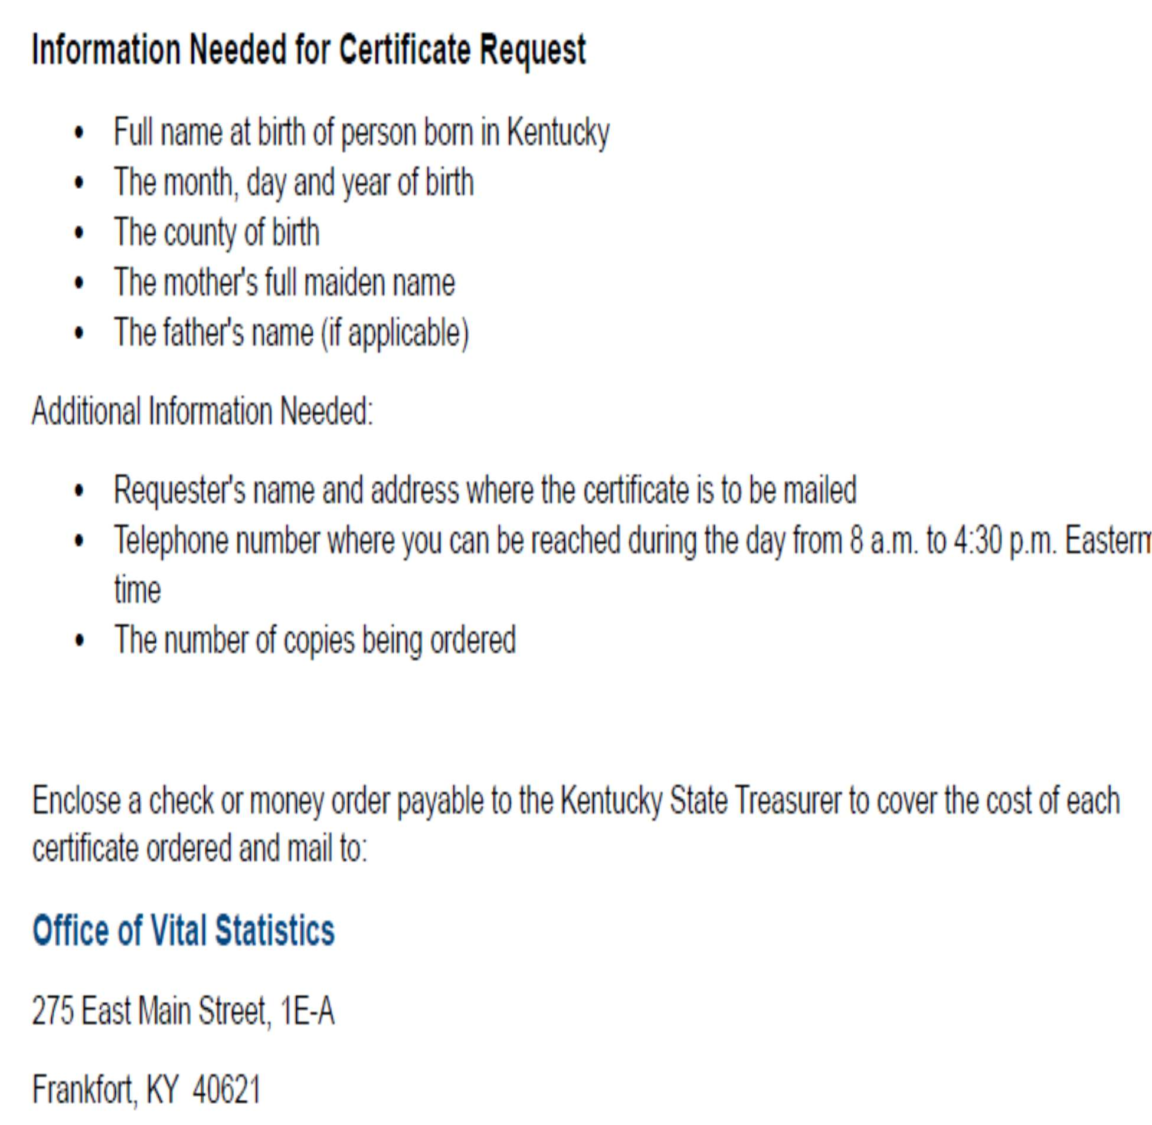

RENTAL HOUSING BENEFITS in NORTHERN KENTUCKY

Kenton County
Covington Housing Authority
Address: 2300 Madison Ave, Covington, KY 41014 Phone: (859) 491-5311
Website: hacov.org/
- Housing Choice Vouchers (Section 8): Online Application Here
- Project-Based Assistance Program: Public Housing
- Senior Housing
Lincoln Grant Scholar House | Northern Kentucky Community Action Commission| 859-581-6607 Housing for single parents who are full-time college students.

Campbell County & Pendleton Counties
Campbell County Department of Housing Administers Section 8 Housing Assistance in Campbell and Pendleton Counties. (CCDH Does Not Provide Assistance in the City of Newport) Address: 1098 Monmouth St, Room 235, Newport, KY 41071 Phone: 859-261-5200 Website: https://campbellcountyky.gov/department/index.php?structureid=31
- Housing Choice Vouchers (Section 8):

City of Newport
Neighborhood Foundations Address: 30 E 8th St, Newport, KY 41071 Phone: (859) 581-2533 Website: https://www.neighborhoodfoundations.com/
- Housing Choice Vouchers (Section 8):
- Senior Housing
- Housing for those with disabilities
- Northern Kentucky Scholar House

Boone County
Boone County Assisted Housing Address: 2950 Washington Street, Burlington, KY 41005 (3rd Floor) Phone: 859-334-2105 Website: Assisted Housing (boonecountyky.org)
- Housing Choice Vouchers (Section 8)

Other Housing Authority Offices in Kentucky
Kentucky Housing Corporation (KHC) offers a variety of rental assistance programs to assist low-income families in securing affordable rental housing through programs such as Project-Based Contract Administration and Housing Choice Vouchers.

Tenant-Based Rental Programs
https://www.kyhousing.org/Rental/HCV/Pages/default.aspx
KHC provides rental assistance directly to applicants through the Housing Choice Voucher (HCV) program, also known as Section 8. This provides a voucher that moves with the recipient to different rental units that accept it.

Project-Based Rental Programs
https://www.kyhousing.org/Rental/HCV/Pages/default.aspx
KHC's Project-Based Contract Administration (PBCA) program provides rental assistance to specific complexes for low-income residents. The subsidy is paid directly to the owner on behalf of the resident. The rental subsidy does not follow the resident from property to property.
Rental Partners https://www.kyhousing.org/Rental/Rental- Partners/Pages/default.aspx
Through the execution of federal Housing Assistance Payment (HAP) contracts, KHC is able to provide rental assistance through the PBCA program and the Tenant-Based Rental Assistance (TBRA) program.

Homelessness Services for Those Experiencing or At-Risk of Shelters in Northern Kentucky

Fairhaven Rescue Mission: 260 W Pike St, Covington, KY 41011 | 859-491-1027 Men | overnight shelter up to 14 days | shower | laundry | clients are subjected to a breathalyzer | Need ID
Emergency Shelter of Northern Kentucky: 436 W 13th Street, Covington, KY 41011 | 859-291-4555 Men 18+ and Women 18+ from November - March
Welcome House Inc.: 1132 Greenup St. Covington, KY 41011 | 859-431-8717 Women and Children’s Shelter | Family Promise shelter through churches and congregations | VA beds
ION Center: 835 Madison Ave. Covington, KY 41011 | 24 Hour Hotline: 859-491- 3335 No-cost shelter for individuals and families fleeing partner violence.
Madonna House of Northern Kentucky: 859-344-1191 Women with children | one-year live-in program to mothers and their children at a reduced monthly rate.
Brighton Center’s Homeward Bound (Youth): 859-581-1111 24-Hour Emergency shelter for runaway, homeless, abused, neglected, and dependent youth ages 11- 17.

At-Risk Services:
St. Vincent De Paul: Homeless Assistance Program (HAP)
This new program provides up to 3 nights in a hotel, food, bus passes and clothing vouchers to a person experiencing homelessness. This program also strives to connect these neighbors to one of our partners who specialize in helping individuals and families find stable and permanent housing. Call the Assistance Phone Line at (859) 341-3219 | Operates from 10 a.m. to 2 p.m., Monday - Friday.
Welcome House: 859-431-8717 Tenant Based Rental Assistance - Rent, Security and Utility Deposit Assistance for qualified households Rapid Re-Housing - connects families and individuals experiencing homelessness to permanent housing through a tailored package of time-limited financial aid and targeted supportive services. Permanent Supportive - supports people with serious mental

illnesses or other disabilities who need professional care, advocacy, and assistance to live stably in their communities.
Northern Kentucky Community Action: 859-484-8450 Tenant Based Rental Assistance
Shelters Resources in Cincinnati Central Access Point (CAP) Helpline: 513-381- SAFE or 513-381-7233 Those who are experiencing homelessness, and those who are at imminent risk of homelessness, can call and be connected to shelter beds or services across multiple agencies and facilities. Intake Specialists can place households on beds in shelters and CAP works to identify the service that can best meet a household’s needs.

Hospitals

St. Elizabeth Florence St. Elizabeth Covington
4900 Houston Rd., Florence, KY 41042 1500 James Simpson Jr. Way Telephone: 859.212.5200 Covington, KY 41011
Telephone: 859.655.8800

St. Elizabeth Edgewood St. Elizabeth Falmouth
1 Medical Village Dr., 512 S. Maple Ave.,
Edgewood, KY 41017 Falmouth, KY 41040
Telephone: 859.301.2000 Telephone: 859.572.3500

St. Elizabeth Ft. Thomas St. Elizabeth Grant
85 N. Grand Ave., 238 Barnes Rd.,
Ft. Thomas, KY 41075 Williamstown, KY 41097
Telephone: 859.572.3100 Telephone: 859.824.8240

Cincinnati Children’s Northern KY 2765 Chapel Place
Crestview Hills, KY 41017 Telephone: 859.344.5390

Medication Assistance Programs
Brighton Center-(859)-491-8303
Community Action Commission Boone-(859) 586-9250
Campbell-(859) 431-4177
Kenton-(859) 581-6607
FAITH Community Pharmacy-859-426-7837

Pharmaceutical Companies that offer free medications to low-income people:
Boehringer Ingelhelm, (800)-556-8317 (Serentil)
Bristol-Meyers Squibb Co., (800)-332-2056 (Buspar/Prollixin/Desyril/Serzone) Eli Lilly Co., (800)-545-6962 (Prozac/Zyprexa)
Pfizer Inc., (866)-706-2400 (Navane/Zoloft/Sinequan) Zeneca Pharmaceuticals, (800)424-3727 (Elavil) Needy Medications, www.needymeds.com

Laundry and Showers (Free) for Homeless

Emergency Shelter of NKY
436 W. 13th Street, Covington, KY.

Florence Christian Church 300 Main Street, Florence, KY (859)-647-5000
https//florencechristian.org/ministries/service/shower-ministry/

PROGRAMS FOR SENIORS & DIFFERENTLY ABLED

DAIL (Department of Aging and Independent Living)
The Kentucky Department for Aging and Independent Living (DAIL) oversees administration of statewide programs and services on behalf of Kentucky elders and individuals with disabilities:
- Programs & Services
- Assisted Living Community Information and Certification
- Caregiver Support Services
- Hart-Supported Living
- Long-Term Care Ombudsman
- Participant Directed Services
- Traumatic Brain Injury Trust Fund

Office of Dementia Services Divisions Guardianship & Quality Living
Agencies Area Agencies on Aging and Independent Living

Assisted Living Services
Assisted living communities may provide:
- Help with personal daily living activities
- Assistance with household and related activities incidental to daily life such as housekeeping, shopping, laundry, chores, transportation and clerical/recordkeeping assistance.
- Daily meals and snacks.
- Scheduled social activities determined by client preferences.
- Help with self-administering medication.

In partnership with Kentucky's Area Agencies on Aging and Independent Living, community mental health centers, Center for Independent Living and other community partners, DAIL provides leadership and addresses issues and circumstances that stand in the way of elders and individuals with disabilities achieving the best possible quality of life.

Because locating, understanding, and accessing public programs and services can be difficult, DAIL helps streamline processes and provides one-on-one assistance by phone. We help clients find the most appropriate programs and services for their needs.
We also have tried to make our website as user-friendly and functional as possible by providing information and links to other resources of interest to elder Kentuckians, people with disabilities and their families.
https://www.chfs.ky.gov/agencies/dail/Pages/aaail.aspx Aging and Independent Living (DAIL), Department contact 275 E. Main St. 3E-E
Frankfort, KY 40621
Phone:(502) 564-6930
Fax:(502) 564-4595
Email: dail.general@ky.gov

Senior Medicare Patrol (SMP)

The Senior Medicare Patrol is a grant- funded national program funded by the Administration for Community Living and the U.S. Department of Health and Human Services.
Senior Medicare Patrol (SMPs): empower and assist Medicare beneficiaries, their families, and caregivers to prevent, detect, and report health care fraud, errors, and abuse through outreach, counseling, and education.
Their work focuses on three main purposes: Conducting outreach and education, engaging volunteers, and receiving beneficiary complaints. The Kentucky senior Medicare Patrol is available to share resources, present to senior centers/ groups, and attend community events.

What do we do?
Outreach & Education
SMP staff and volunteers regularly attend local conventions, expos, and community events to spread the word about Medicare fraud. We also regularly present educational material to seniors and caregivers at senior centers around Kentucky.

Engage Volunteers
The SMP is a national volunteer program with over 5000+ volunteers nationwide.
SMP volunteers perform a wide array of services for the SMP, from doing administrative tasks to assisting beneficiaries with their questions about Medicare fraud.

(SMP Cont.) Case work
Beneficiaries come to the SMP for assistance and guidance with concerns about Medicare fraud. The SMP helps Beneficiaries through the processes of determining if fraud has occurred and reporting it to the paper authorities.
Become an SMP Volunteer: SMP volunteers may serve Medicare beneficiaries, their families, and caregivers in many ways:
- Assist with administration
- Distribute information
- Staff exhibits
- Make group presentations
- Counsel
- Manage complex interaction
- To volunteer call: 877-603-6558

Contact Information

Name: Michelle List Phone Number: (502) 574-6960
Email: michelle.list@louisvilleky.gov Website: https://www.smpresource.org/

Name: Katie Deno (Volunteer Supervisor) Phone Number: (859) 491-8303 ext. 2336 Email: kdeno@brightoncenter.com
https://www.brightoncenter.com/programs/senior_services/senior- medicare-patrol

Employment Services:
Citizen Connect: Kentucky unemployment insurance claimants must register with Citizen Connect to ensure program eligibility. Create your free account to take advantage of educational and workforce-related services.
Kentucky Career Portal: The Kentucky Career Center now offers job seekers the ability to search for jobs by location on the new Kentucky Career Portal.
Employers can create an account and post jobs for free.
Kentucky Career Centers: If you need in-person job search or resume assistance, please visit any Kentucky Career Center during normal business hours. No appointment is necessary, and walk-ins are welcome. Find a Kentucky Career Center office near you.

If you need immediate assistance, contact:
KentuckyCareerCenterSupport@ky.gov or call (502) 564-0871, Monday - Friday, 8
a.m. to 4:30 p.m. EST.
Office of Vocational Rehabilitation | 859-292-6513 OVR provides vocational rehabilitation services to eligible individuals with disabilities to assist with entry or re-entry into employment and productivity in the workplace and community.
SNAP Employment and Training: All SNAP recipients age 16 to 60 are eligible to participate. SNAP E&T may be for you:
  - If you need help meeting a SNAP work requirement
  - If you want to get your GED or take college courses
- If you want training in a new field or trade such as welding or plumbing
  - If you want budgeting and financial training
- If you're having a hard time finding a job because of barriers in your past
  - If you want to find a job and don't know where to start
    - If you want advice on your current job or career

(Employment Services Cont.)
Kentucky Campus Compact AmeriCorps VISTA | 859-572-7837 Through AmeriCorps VISTA, Kentucky Campus Compact is able to expand our reach and place over 50 VISTA members to member colleges and universities as well as nonprofit organizations throughout Kentucky communities that are combating poverty.
KYCC VISTA members achieve the AmeriCorps anti-poverty goals through indirect service activities in the areas of economic development and opportunity, organizational capacity building, Pre-K to Post-Secondary educational programming, nutritional and community health awareness, leadership development, and assisting veteran and military families.
Work Ready Kentucky Scholarship: The Scholarship is available to KY residents with a high school diploma or working on their GED that do not already have an associate’s degree or higher. Apply at Kheaa.com

For a detailed employment referral, please contact District 7 Probation and Parole Officer and inquire about a referral to Reentry Employment Program Administrator, William Wild, (859) 391-7593

